AnswerBot- AI-powered FAQ and customer support automation.
DISCRIPTION:
AnswerBot is an AI-powered customer support system designed to provide quick and accurate answers to frequently asked questions. It uses artificial intelligence and natural language processing to understand user queries and provide relevant responses automatically. The system reduces the need for manual customer support by handling common questions, guiding users, and providing instant assistance 24/7. It can maintain FAQ information, manage customer queries, and improve the support experience through an easy-to-use interface. AnswerBot helps organizations save time, reduce support workload, and deliver faster and more consistent customer service.

Scenario-Based Case Study – AnswerBot
Case Study: Automated Customer Support for an Online Shopping Company
Scenario:
An online shopping company receives hundreds of customer queries every day regarding product availability, order status, payment methods, delivery time, return policies, refunds, and account-related issues. Currently, customer support executives manually answer most of these questions. Since many queries are repetitive, customers often have to wait for a response, especially during peak hours.
To solve this problem, the company introduces AnswerBot – AI-Powered FAQ and Customer Support Automation. Customers can enter their questions through a web-based chat interface. AnswerBot analyzes the user's query using Natural Language Processing (NLP), identifies the relevant FAQ or knowledge-base information, and provides an appropriate response instantly.
For example, if a customer asks “How can I return my product?”, AnswerBot recognizes the intent as a return-related query and provides the company's return procedure. If the question cannot be answered from the available knowledge base, the system can indicate that the query requires human support.
Problem Statement
Traditional customer support systems depend heavily on human agents to answer customer queries. A large portion of these queries are repetitive and can consume considerable time and resources. Customers may also experience delays in receiving responses, particularly when the number of queries increases.
Therefore, there is a need for an AI-powered automated FAQ and customer support system that can:
- Provide instant responses to frequently asked questions.
- Understand customer queries using natural language processing.
- Reduce repetitive workload for customer support staff.
- Maintain and retrieve FAQ information efficiently.
- Provide consistent responses to common questions.
- Identify queries that cannot be answered automatically and direct them for further assistance.
- Improve the overall speed and accessibility of customer support.
Proposed Solution
AnswerBot provides an automated conversational interface where customers can ask questions in natural language. The system processes the query, matches it with the available FAQ/knowledge base, and returns the most relevant answer. This creates a faster support process while leaving complex or unsupported cases for human representatives.
. Software Requirements
- Operating System: Windows 10/11, macOS, or Linux (supports cross-platform operations).
- Node.js (v18 or above): Runtime ecosystem running server logic and routing infrastructure.
- npm (v9 or above): Node package manager to control operational dependencies.
- Express.js (v4/v5 Ecosystem): Lightweight routing web framework to construct backend RESTful entry points.
- MongoDB / Mongoose ODM: Document NoSQL engine storing application users and curated data entities.
- Postman / ThunderClient: API verification toolkit to assert schema validation responses across administrative route shields.
- Code Editor: Visual Studio Code or similar IDE environment.
2. Hardware Requirements
- Processor: Intel Core i5 (8th Gen or above) / AMD Ryzen 5 or equivalent.
- RAM: 8 GB minimum (16 GB recommended for concurrent instances of MongoDB processing layers).
- Storage: 1 GB of available disk workspace.
Epic-1: Project Architecture
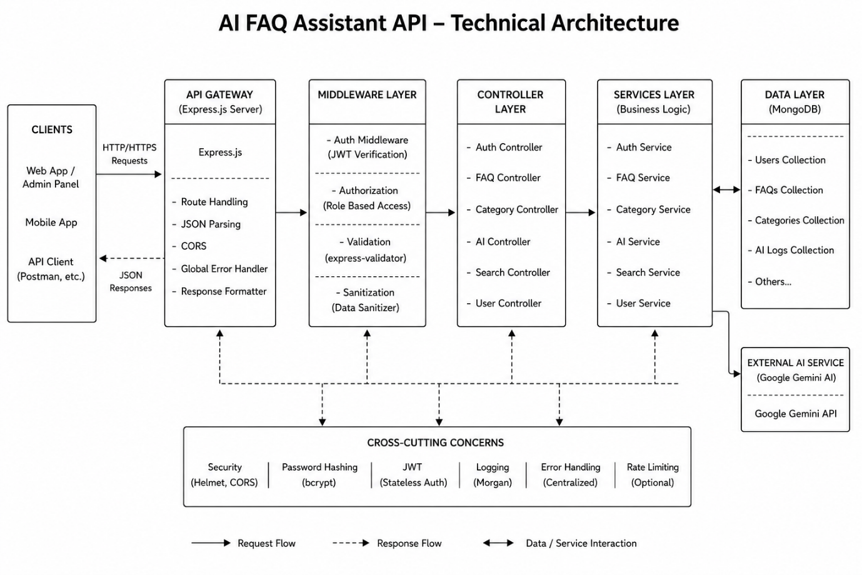
The AI FAQ Assistant application exposes structured endpoints handled by a layered server architecture model. Incoming requests undergo filter processing before interacting with data services.
Components Definition
- Interface: API tools like Postman query distinct route paths to extract JSON entities.
- Express Server Gateway: Monitors network ports, maps explicit HTTP methods (GET, POST, PUT, DELETE), parses incoming JSON payloads, and handles CORS headers.
- Authentication Middleware: Extracts tokens from headers, validates user context signatures, and evaluates authorization thresholds for guarded resource paths.
- Granular Services (Logic Modules): Enforces isolated domain rules for user session life cycles and operational query modifications.
- Database Interface Layer: Mongoose translates operational application logic into performant native MongoDB queries.
- AI Flow (Service Integration): Connected to external AI models via Google Gemini SDK integrations, letting the controller layer offload complex question-answering tasks and automated topic generation workflows.
Entity-Relationship (ER) Diagram Description
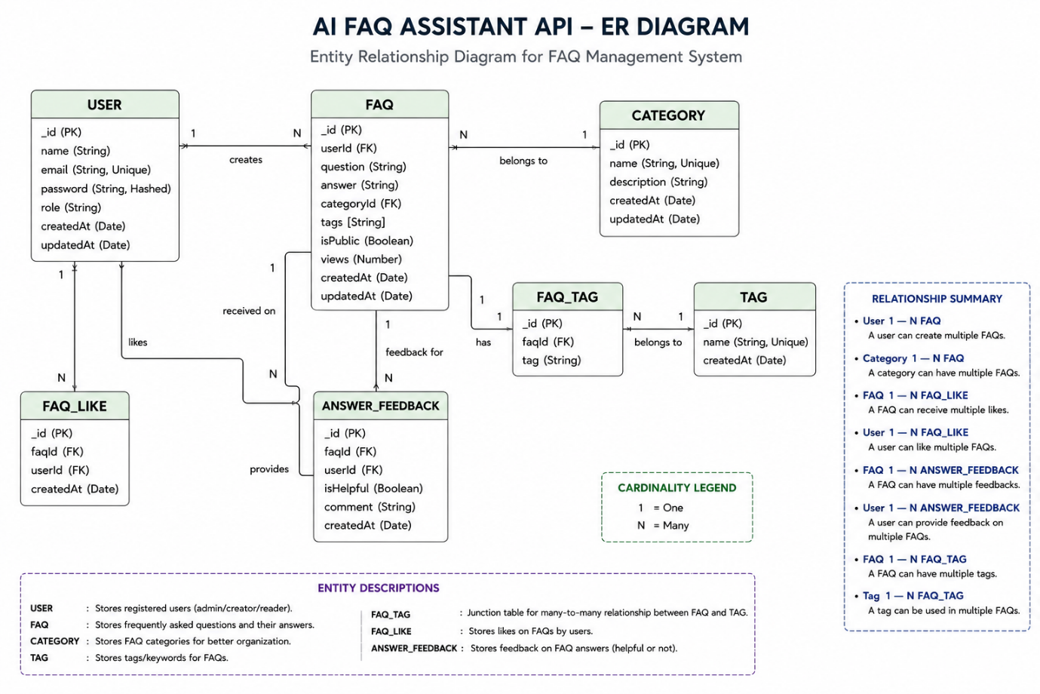
The backend database consists of multiple MongoDB collections connected through logical references to maintain user authentication, FAQ management, AI-generated content, and category organization.

1. User Entity
- _id (Primary Key - ObjectId)
- name (String, Required)
- email (String, Required, Unique)
- password (String, Hashed, Required)
- role (String, Default: "user")
- createdAt
- updatedAt

2. FAQ Entity
- _id (Primary Key - ObjectId)
- question (String, Required)
- answer (String, Required)
- category (String, Required)
- createdBy (Foreign Key referencing User Collection)
- createdAt
- updatedAt

3. AI Generation Entity (Logical)
(Generated dynamically using Google Gemini AI before persistence.)
- topic (String)
- generatedQuestion (String)
- generatedAnswer (String)
- generatedCategory (String)
- generatedAt

4. Category Entity (Logical)
- categoryName (String)
- description (String)
- totalFAQs (Number)

Key Structural Mappings
User → FAQ (One-to-Many):
A registered user can create and manage multiple FAQ records.
Category → FAQ (One-to-Many):
Each category can contain multiple FAQ documents.
User → AI Generated FAQ (One-to-Many):
A user can generate multiple AI-assisted FAQs, which may later be saved into the FAQ collection.
FAQ → Search Results (Logical Relationship):
Search queries retrieve matching FAQ documents using keyword and semantic matching.

Key Features
- JWT Authentication & Authorization: Secure token-based authentication protects private API endpoints.
- AI FAQ Generation: Google Gemini AI automatically generates questions, answers, and topic suggestions.
- Semantic FAQ Search: Intelligent keyword-based search enables faster information retrieval.
- Complete CRUD Operations: Create, Read, Update, and Delete FAQ records.
- Category Management: Organizes FAQs into structured categories for easier navigation.
- Password Encryption: User passwords are securely hashed using bcrypt before storage.
- Centralized Error Handling: Standardized API error responses improve reliability and debugging.
- Schema Validation: Mongoose validation ensures data integrity before database persistence.
- RESTful API Architecture: Modular Express.js routes provide scalable backend services.
- MongoDB Integration: Efficient NoSQL document storage using Mongoose ODM.

Roles and Responsibilities
Admin
- Manage all registered users.
- View, update, and delete any FAQ.
- Monitor AI-generated content.
- Manage FAQ categories.
- Access complete system functionality.
Content Creator
- Create new FAQs.
- Edit personal FAQ records.
- Delete owned FAQs.
- Generate FAQs using AI.
- Organize FAQs under categories.
Authenticated User
- View public FAQs.
- Search FAQs using keywords.
- Generate AI-assisted answers.
- Access personal profile information.
Public User
- View published FAQs.
- Search FAQs.
- Cannot create, edit, or delete FAQ records.
- No access to protected API endpoints.

User Flow
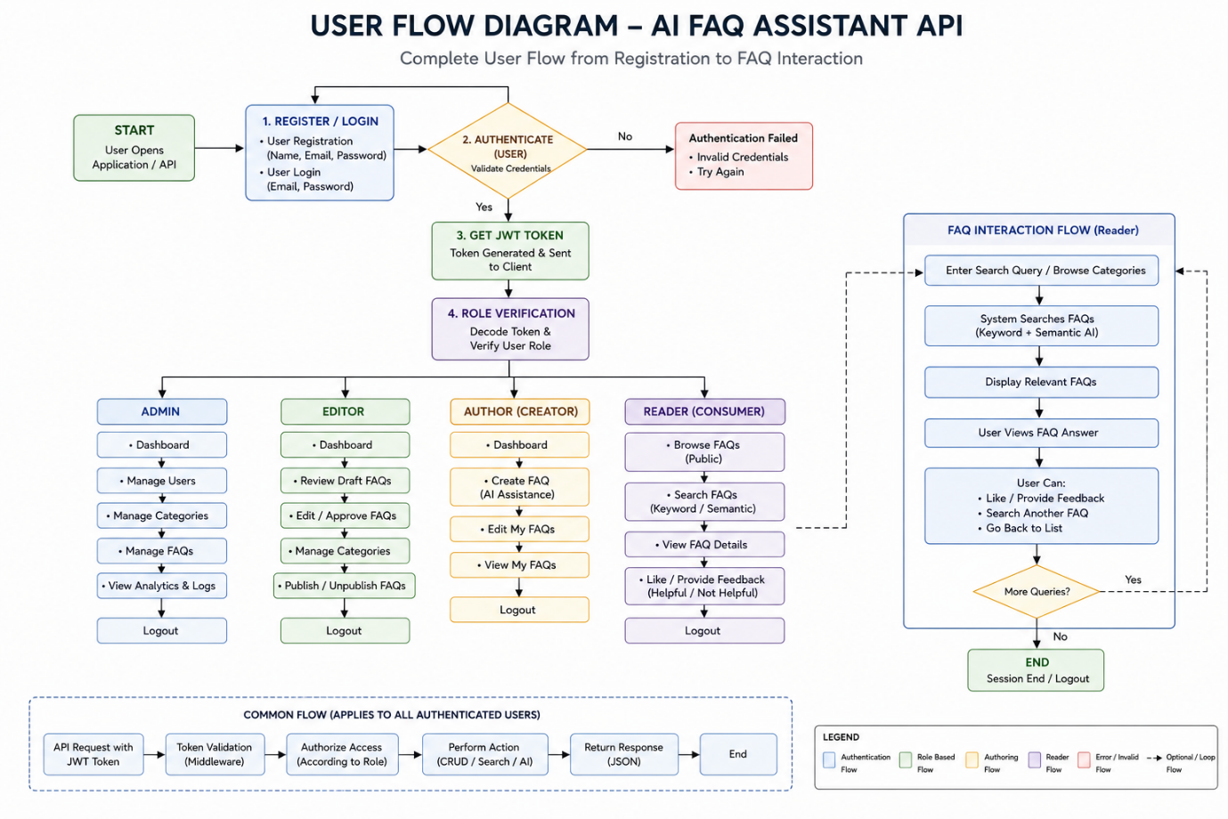
MVC Architecture Pattern
The system architecture structures its source configuration layers around the Model-View-Controller design pattern to completely decouple components:
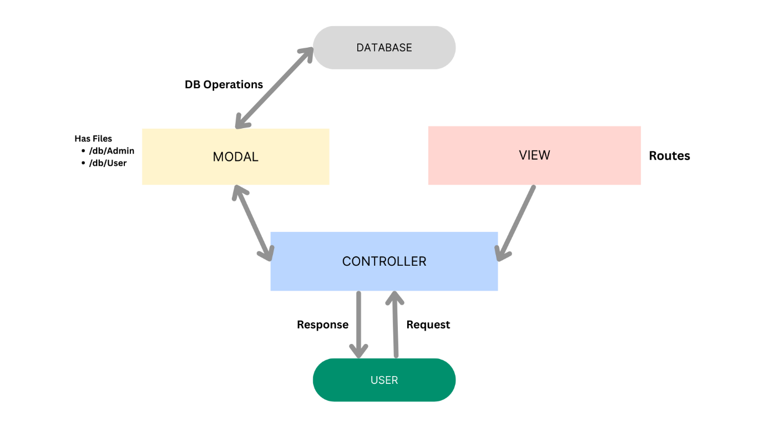

The system architecture structures its source configuration layers around the Model-View-Controller design pattern to completely decouple components:
Model Layer (Data Blueprint)
Defines structural blueprints via strongly enforced Mongoose schemas mapping explicit fields into raw collection items inside MongoDB. It sets field rules and defaults before validation persistence occurs.
Controller Layer (Execution Matrix)
The intermediary brain of the ecosystem. It captures request vectors from execution routes, checks structural request constraints, delegates processing workflows directly to models or services, and packages resultant output into standard JSON return arrays.
View Layer (Routing Network Interface)
In this pure headless backend service context, standard user-interface template views do not exist. Instead, the interface layer lives as an API Routing Layer. It links network requests on specified paths directly to their associated controller handler logic maps.
Epic 2: Project Setup and Configuration
Creating Project Folder
- Create a new folder with your <project name>.
- Inside that folder, create a new subfolder named src.
- Now open that folder in VS Code.
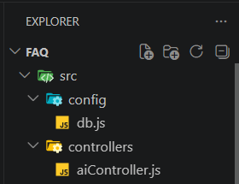
Server Setup (npm init)
Open your root folder terminal in VS Code and run:
Bash

npm init -y
npm install express mongoose dotenv cors jsonwebtoken bcrypt @google/genai
File and Folder Structure Matrix
Plaintext

Epic 3: Backend Development

Core System Script Implementations
1. Gateway Server Node (src/server.js)
This main entrance mechanism aggregates environment variables, triggers database listeners, and binds network listeners to active environment ports:

2. Gateway Express Setup (src/app.js)
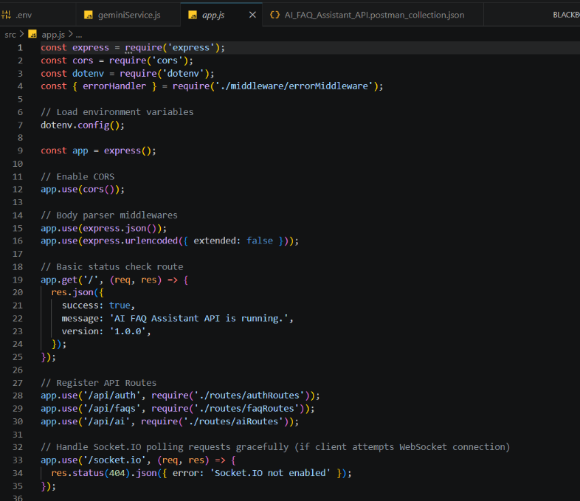
3. Security Access Middleware (src/middleware/authMiddleware.js)
Intercepts incoming target queries, extracts transmission header authorization records, and validates token identity context claims:
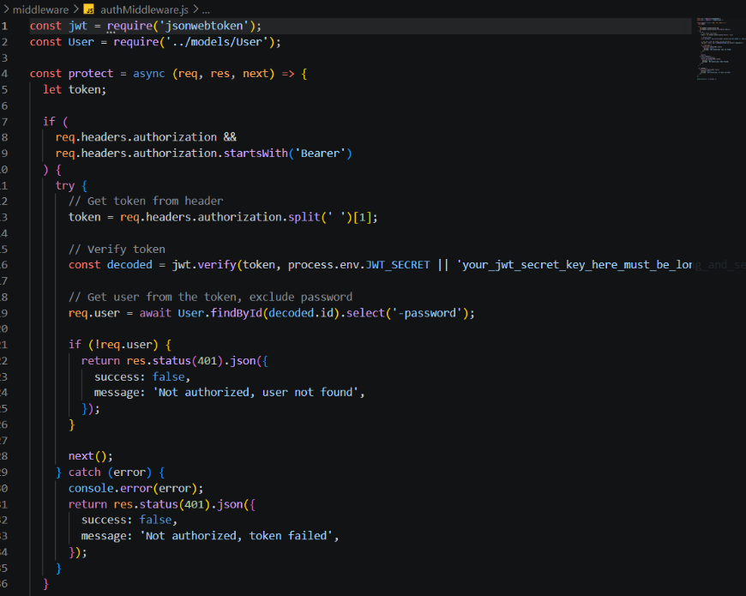
4. Centralized Error Handler Middleware (src/middleware/errorMiddleware.js)

Epic 4: Database Configuration
Mongoose Schema Definitions
1. Identity Resource Document Schema (src/models/User.js)
Enforces profile field criteria validations and hooks password hashing steps prior to user document persistence:
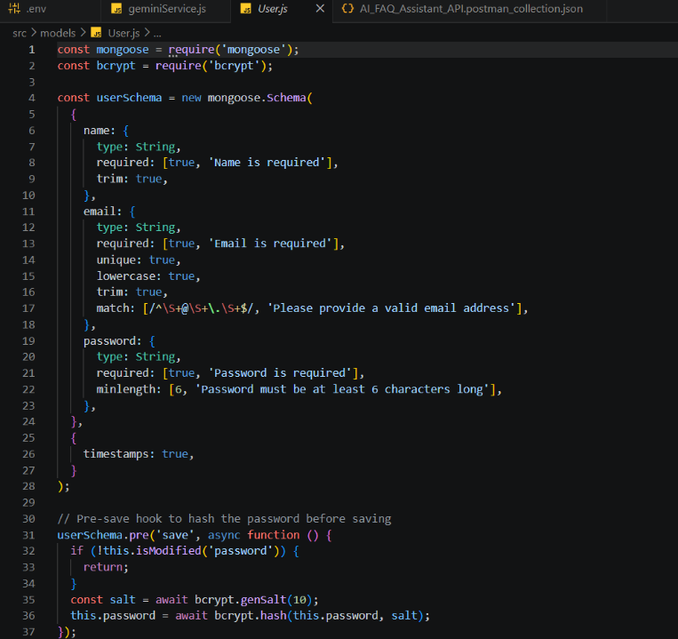
2. FAQ Resource Document Schema (src/models/FAQ.js)
Models core properties and maps a distinct relational reference link back to the source creator document:

API Router Interface Endpoints
1. Public Authentication Operations (src/routes/authRoutes.js)

2. Protected FAQ Operations (src/routes/faqRoutes.js)
JavaScript

3. AI Automation Operations (src/routes/aiRoutes.js)

Epic 5: Project Executions
Running the API Application
- Install Postman or ThunderClient (VS Code extension).
- Start the backend development server environment parameters:
Bash

npm run dev
API Testing Specification Demo
To verify operational structural integrity via execution endpoints, map endpoints using the configurations below:
1. Identity Onboarding Path Registration
- Route: POST /api/auth/register
- Access: Public
- Payload Request Body JSON:
JSON

{
"name": "Priya Sharma",
"email": "priya@writeflow.com",
"password": "securepassword123"
}

2. Profile Login Verification Quey
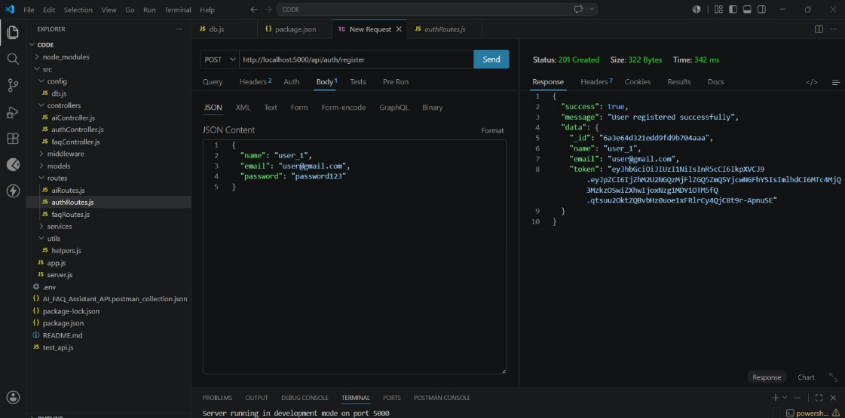
- Route: POST /api/auth/login
- Access: Public
- Payload Request Body JSON:
JSON

{
"email": "priya@writeflow.com",
"password": "securepassword123"
}
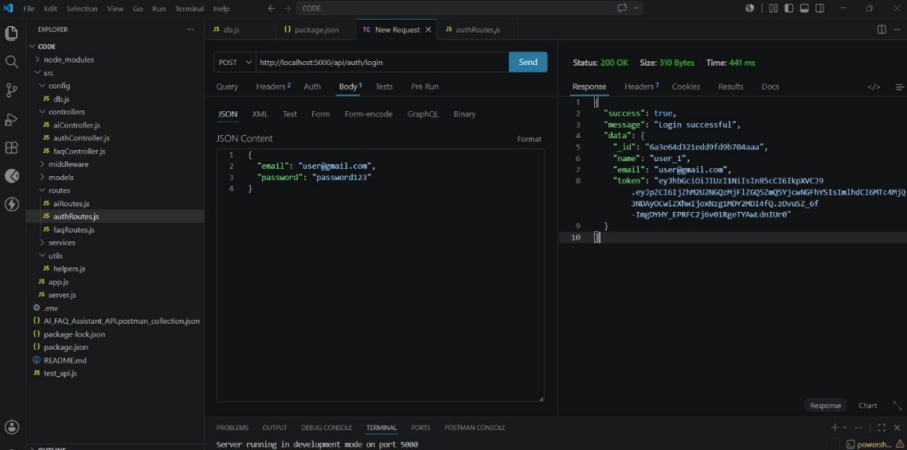
3. Resource Entity Creation (FAQ)
- Route: POST /api/faqs
- Access: Private (Bearer <JWT Token>)
- Payload Request Body JSON:
JSON

{
"question": "How do I configure custom category tags?",
"answer": "Navigate to settings panel, append keyword tags arrays, and save schema.",
"category": "Configuration"
}
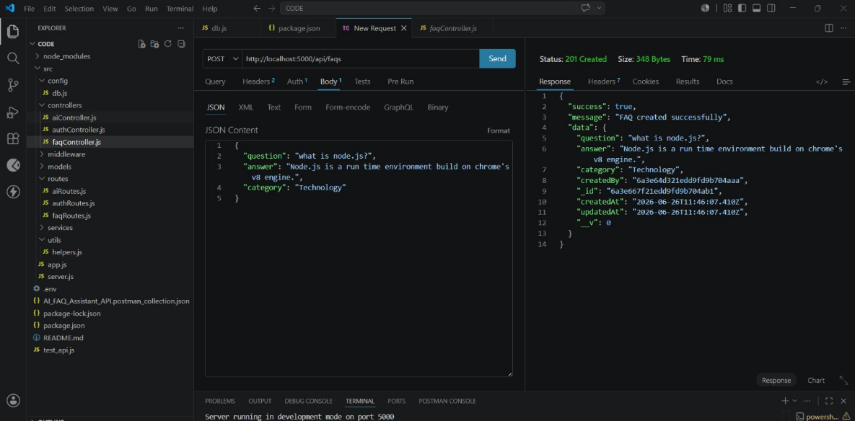
4. Keyword Resource Entity Fetching (Search)
- Route: GET /api/faqs/search?q=configure
- Access: Public

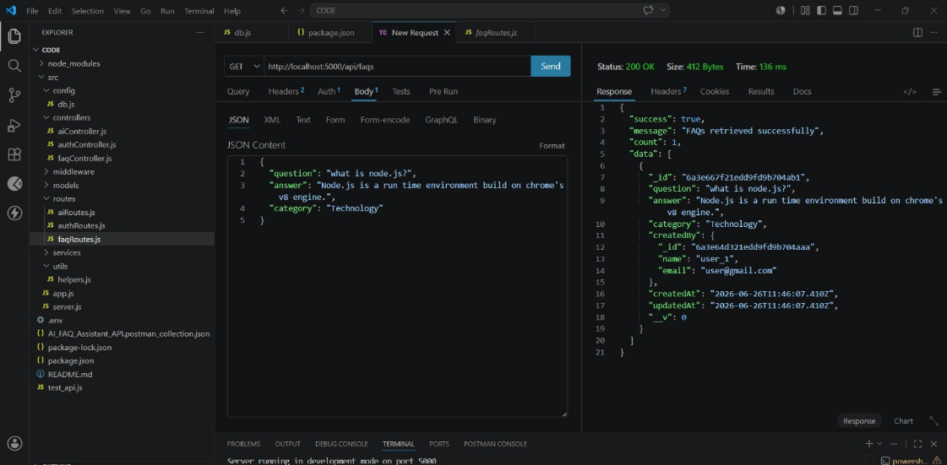

5. AI Intelligent Content Automation (Generate FAQ Pair)
- Route: POST /api/ai/generate-faq
- Access: Private (Bearer <JWT Token>)
- Payload Request Body JSON:

